Top of Form

Functions

**stepanyanm17@gmail.com** [Switch account](https://accounts.google.com/AccountChooser?continue=https://docs.google.com/forms/d/e/1FAIpQLSegQ1tNkDWteB50wex-ltITcTSEk197oBNEIyMoQcIbOQVWOg/viewform?usp%3Dsend_form&service=wise)

Not shared

* Indicates required question

Անուն Ազգանուն*



Your answer

This is a required question

What will be the output of the following code?

i = 14  
def foo(val: int)->bool:  
 return val % 2 == 0  
  
  
if foo(i):  
 def my_func():  
 print('if statement')  
else:  
 def my_func():  
 print('else statement')  
  
my_func()

10 points

else statement

SyntaxError: can't define function in if statement

ArgumentError

if statement

What does the acronym "LEGB" stand for in Python?

10 points

Local, Enclosing, Global, Block

Local, External, Global, Block

Local, Enclosing, Global, Built-in

Local, External, Global, Built-in

What does the yield statement do in Python?

10 points

It returns a value from a generator function.

It terminates the execution of a function.

It raises an exception in Python.

It defines a variable within a function.

What will be the output of the following code?

i = 12

def foo():

print(i)

i = 24

foo()

print(i)

10 points

UnboundLocalError

12

24

How can you access the global variables within a function in Python?

10 points

By importing the global variables from another module.

By passing the global variables as arguments to the function.

By using the globals() function within the function.

By using the global keyword before the variable name.

How can you obtain both the index and value of each element in a sequence using a for loop?

10 points

By using the range() function with the length of the sequence.

By using the enumerate() function in combination with the for loop.

By using the map() function with a lambda function.

By using the index() method of the sequence.

What will be the output of this code?

def my_function(a, b=10):

return a + b

result = my_function(5)

print(result)

10 points

10

15

5

ArgumentError

What will be the output of this code?

10 points

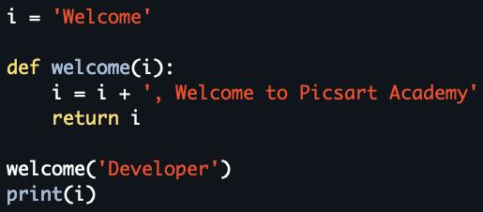

Developer, Welcome to Picsart Academy

Welcome

Error

Nothing to display

What will be the output of this code?

10 points

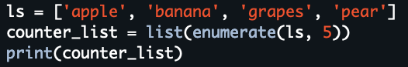

[[5, 'apple'], [6, 'banana'], [7, 'grapes'], [8, 'pear']]

(5, 'apple', 6, 'banana', 7, 'grapes', 8, 'pear')

[5, 'apple', 6, 'banana', 7, 'grapes', 8, 'pear']

[(5, 'apple'), (6, 'banana'), (7, 'grapes'), (8, 'pear')]

What is the purpose of the lambda keyword in Python?

10 points

It is used to define a function with no arguments.

It is used to define a function with single argument

It is used to define a function with a single expression, often used as a shorthand.

It is used to define a generator function.

Submit

Clear form

Never submit passwords through Google Forms.

Bottom of Form

This content is neither created nor endorsed by Google. [Report Abuse](https://docs.google.com/forms/u/0/d/e/1FAIpQLSegQ1tNkDWteB50wex-ltITcTSEk197oBNEIyMoQcIbOQVWOg/reportabuse?source=https://docs.google.com/forms/d/e/1FAIpQLSegQ1tNkDWteB50wex-ltITcTSEk197oBNEIyMoQcIbOQVWOg/viewform?usp%3Dsend_form) - [Terms of Service](https://policies.google.com/terms) - [Privacy Policy](https://policies.google.com/privacy)

[Forms](https://www.google.com/forms/about/?utm_source=product&utm_medium=forms_logo&utm_campaign=forms)